TRANSMISSION LINES & WAVEGUIDES – ECA1501

EXPERIMENT – 4
Name | Noorbasha Chotu | Reg. No. | 192412383
Date | 16/10/2026 | Experiment No. | 4

Strategize Impedance Matching With Characteristic Impedance And Load Impedance Through The Measurement Of A) Location Of The Stub B) Length Of The Stub

AIM
To design strategize impedance matching with characteristic impedance and load impedance through the measurement of a) location of the stub b) length of the stub.

SOFTWAREREQUIRED:

SCILABVersion6.1.1

PROCEDURE:

●Open SCILAB software

● Open file-new

● Put the input values

● Type the program

● Execute the program

● End the program

PROGRAM:

clc;
clear;
Zo = 60;
f = 100 * 10^6;
lambda = 3 * 10^8 / f;
printf("ZR(Ohms)\tPoint of attachment(cm)\tStub length(cm)\n");
for ZR = 100:50:350
theta = 30 * %pi / 180;
ZL = ZR * (cos(theta) + %i * sin(theta));
zL = ZL / Zo;
yL = 1 / zL;
g = real(yL);
b = imag(yL);
A = g - g^2 - b^2;
B = -2 * b;
C = g - 1;
D = B^2 - 4 * A * C;
if D >= 0 then
t1 = (-B + sqrt(D)) / (2 * A);
d = atan(t1);
if d < 0 then
d = d + %pi;
end
y = (yL + %i * tan(d)) / ...
(1 + %i * yL * tan(d));
bs = -imag(y);
ls = atan(bs);
if ls < 0 then
ls = ls + %pi;
end
printf("%d\t\t%.2f\t\t\t%.2f\n", ...
ZR, lambda*d/(2*%pi)*100, ...
lambda*ls/(2*%pi)*100);
else
printf("%d\t\tNo real solution\n", ZR);
end
end

TEST CASE 1

Optimize impedance matching using single stub matching by finding the location and length of the stub for the values of load impedance of 100 30o to 350 30o keeping the characteristic impedance Zo= 60 Ω constant .

OUTPUT TABLE 1

Variables ZR;
Input | Output
Constants Zo = 60Ω; f=100*(10^6);
ZR  Ohms. angle 30o | Point of attachment | Length of short-circuited  stub (cm)
100∠30° | 28.46 | 141.82
150∠30° | 39.45 | 124.77
200∠30° | 45.12 | 115.55
250∠30° | 48.76 | 109.70
300∠30° | 51.35 | 105.61

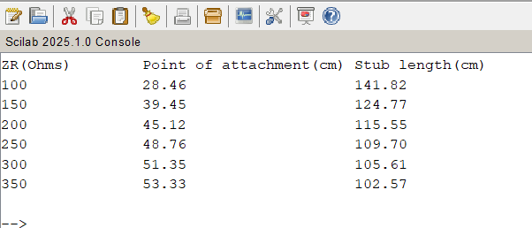

RESULT:

Impedance matching using single stub matching is optimized by calculating the location and length of the stub
or varying values of load impedance keeping the characteristic impedance Zo= 60 Ω constant .

TEST CASE 2
Optimize impedance matching using single stub matching by finding the location and length of the
stub for the values of characteristic impedance ranging from 600Ω to 1800 Ω. Keeping the load
impedance ZR= 100 30o constant .

OUTPUT:

Input | Output
Variables Z0;
Constants ZR= 100 30o Ω; f=100*(10^6);
Z0  Ohms. angle 30o | Point of attachment | Length of short-circuited  stub (cm)
600 | 128.67 | 19.87
900 | 132.98 | 15.76
1200 | 135.48 | 13.44
1500 | 137.15 | 11.91
1800 | 138.37 | 10.81

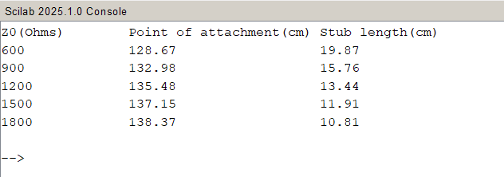
RESULT:

Impedance matching using single stub matching is optimized by calculating the location and
length of the stub for varying values of characteristic impedance keeping the load impedance
constant .

